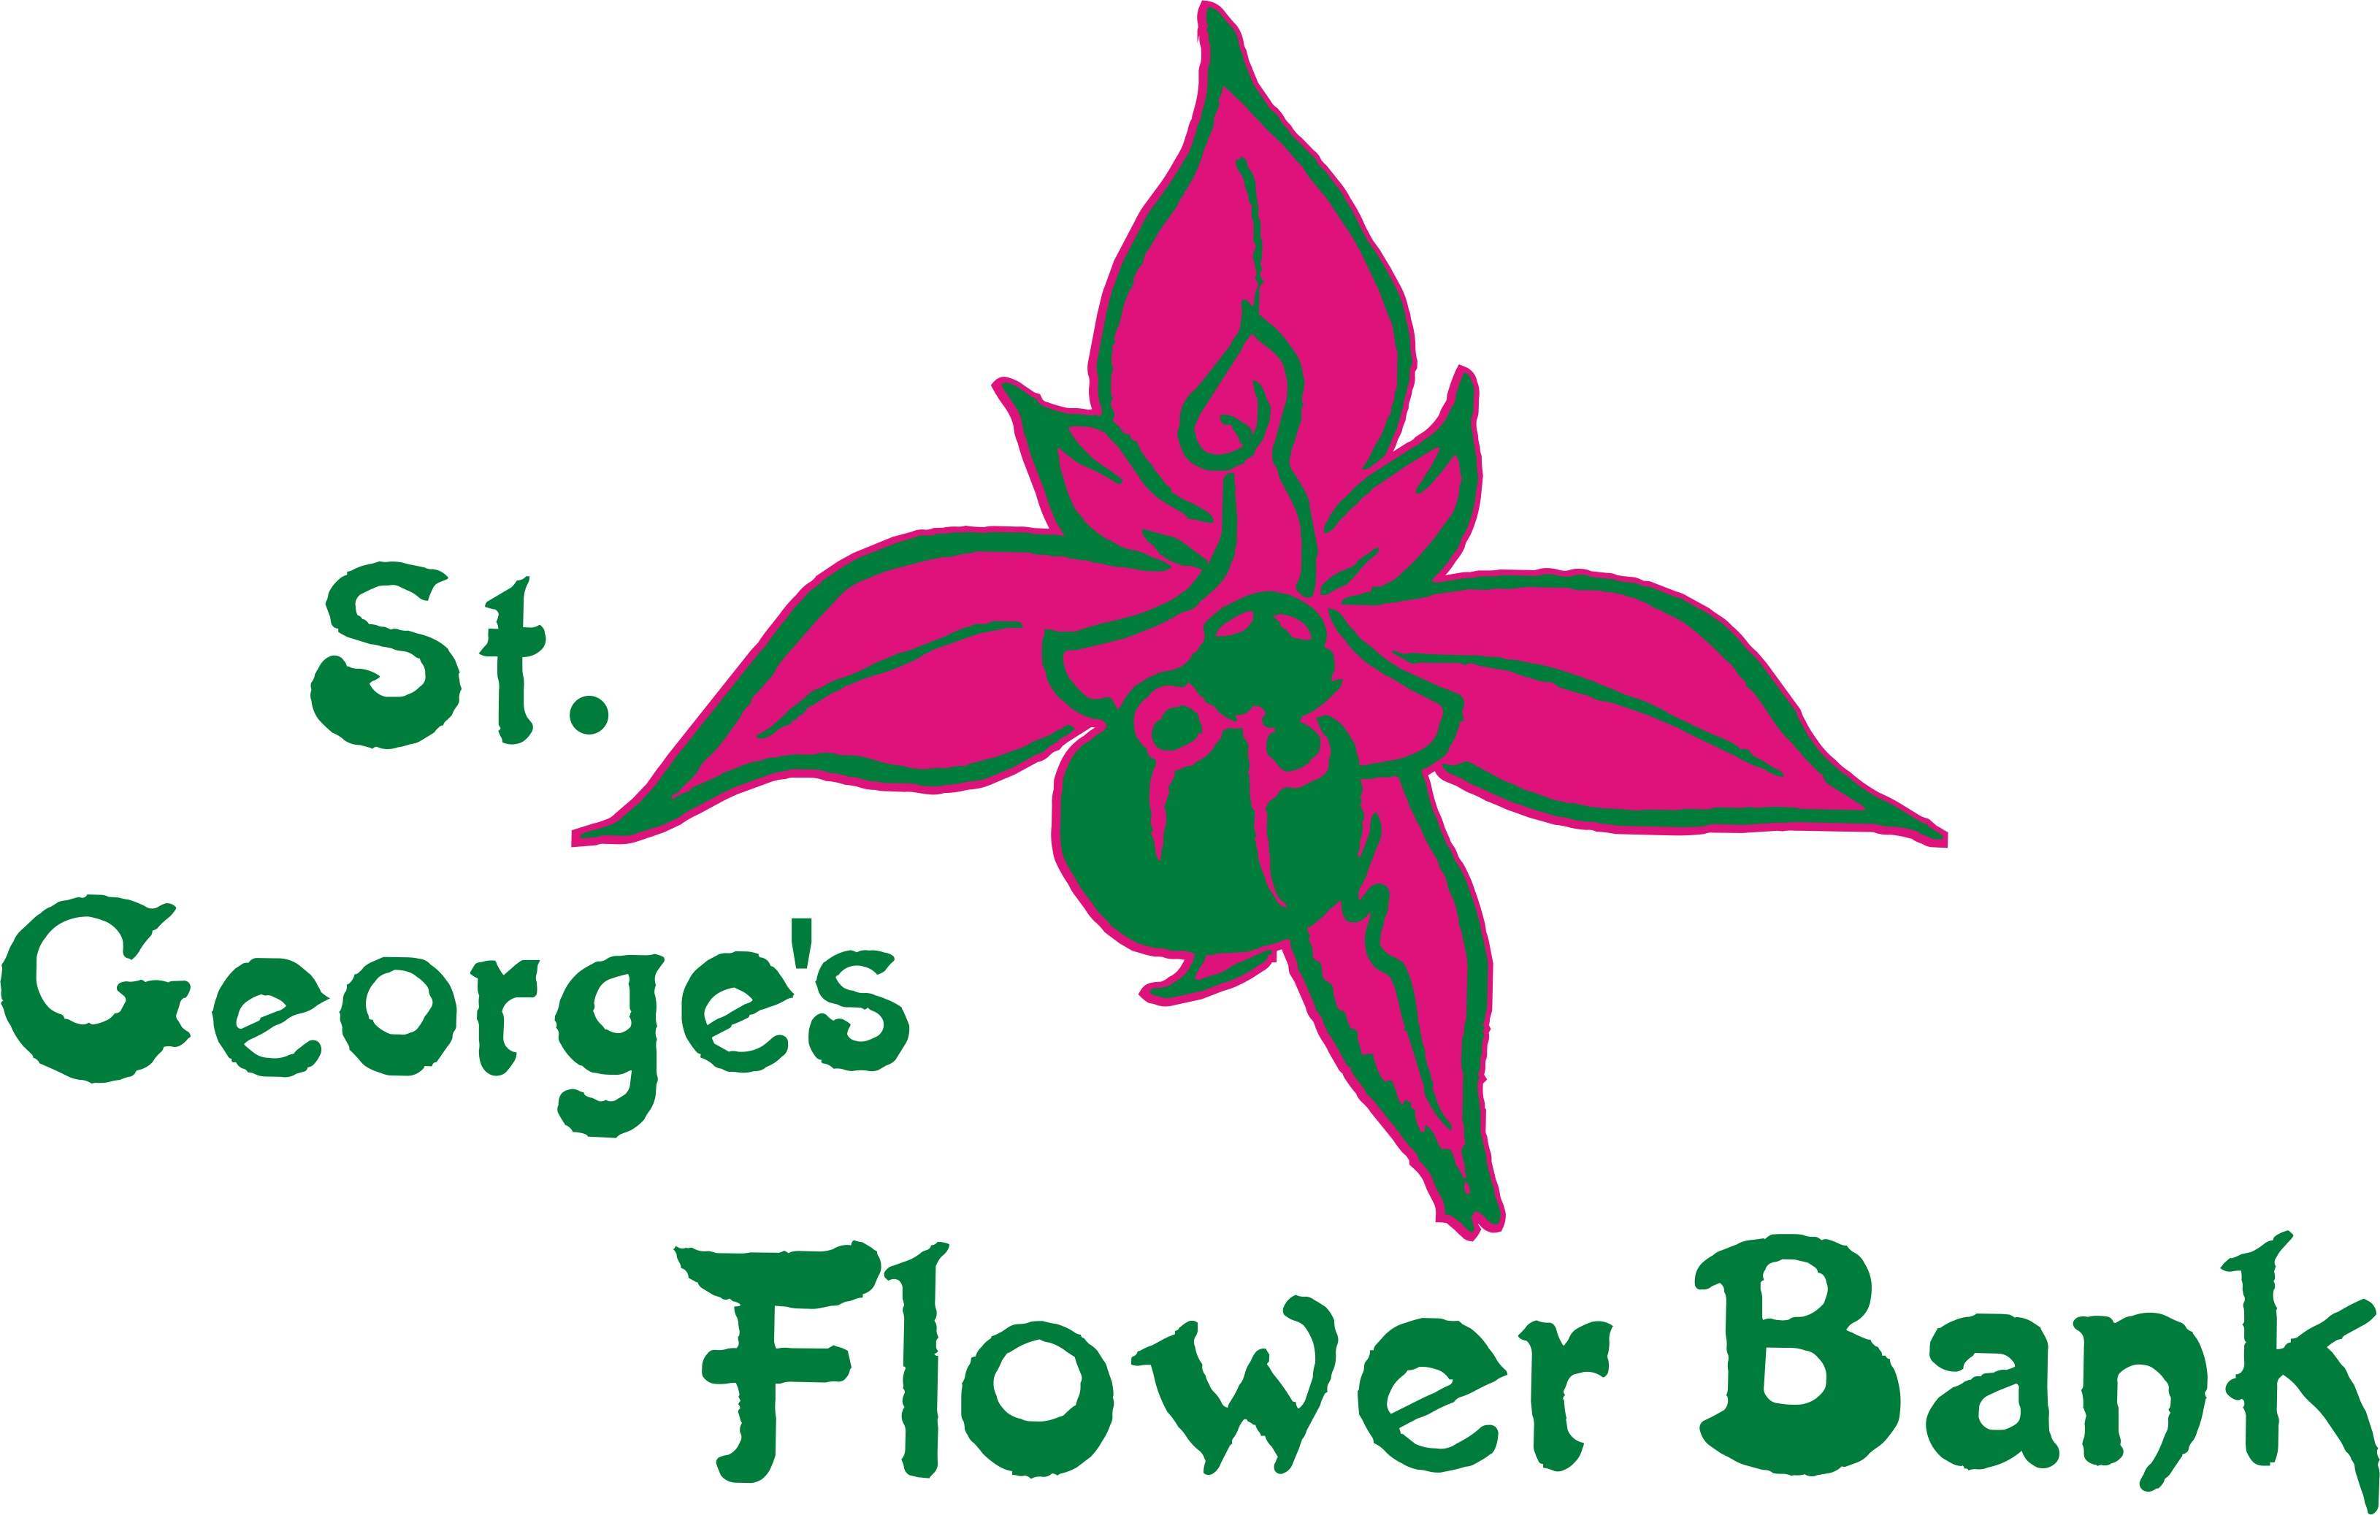
Autumn 2023 Newsletter

It’s well and truly autumnal now, the Swifts have long gone, though Swallows are still being reported in good numbers suggesting they may have had a good breeding season but….

Here’s a reminder of the State of Nature Report – not happy reading
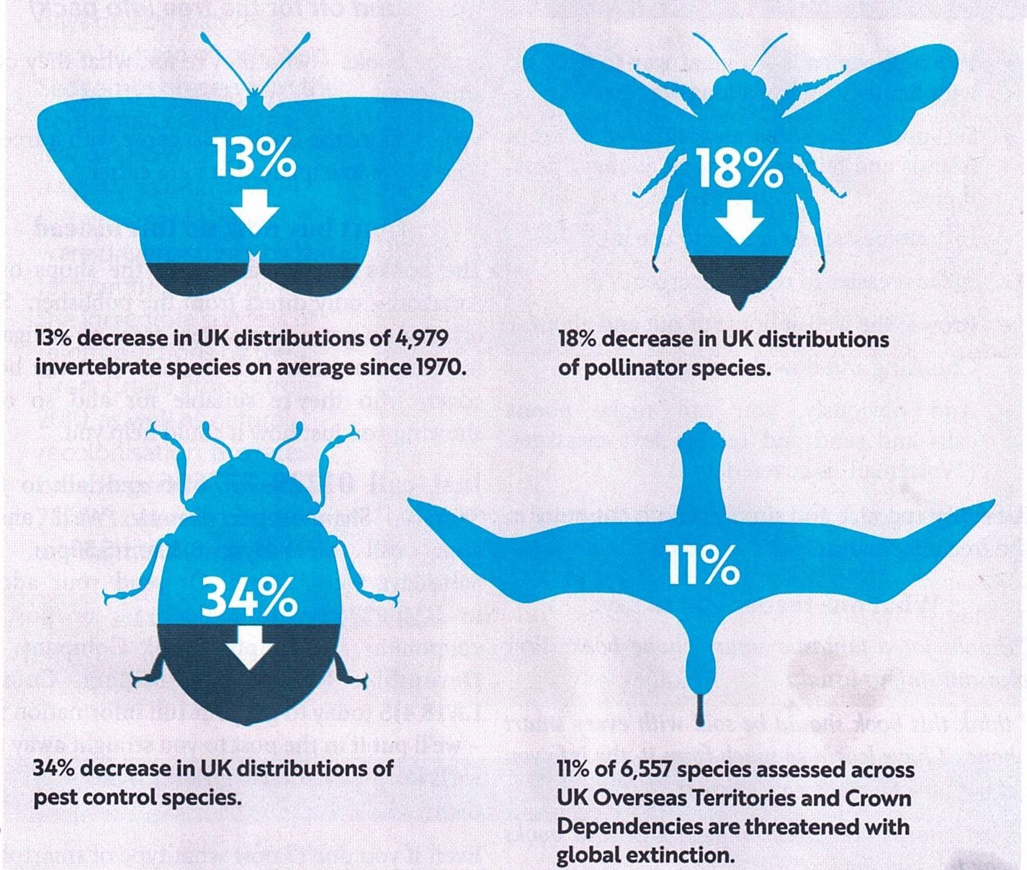

https://stateofnature.org.uk/

We all need to keep working at this
# # # # #
Despite the long hot spell early in the season we’ve had a great display on the Flower Bank.
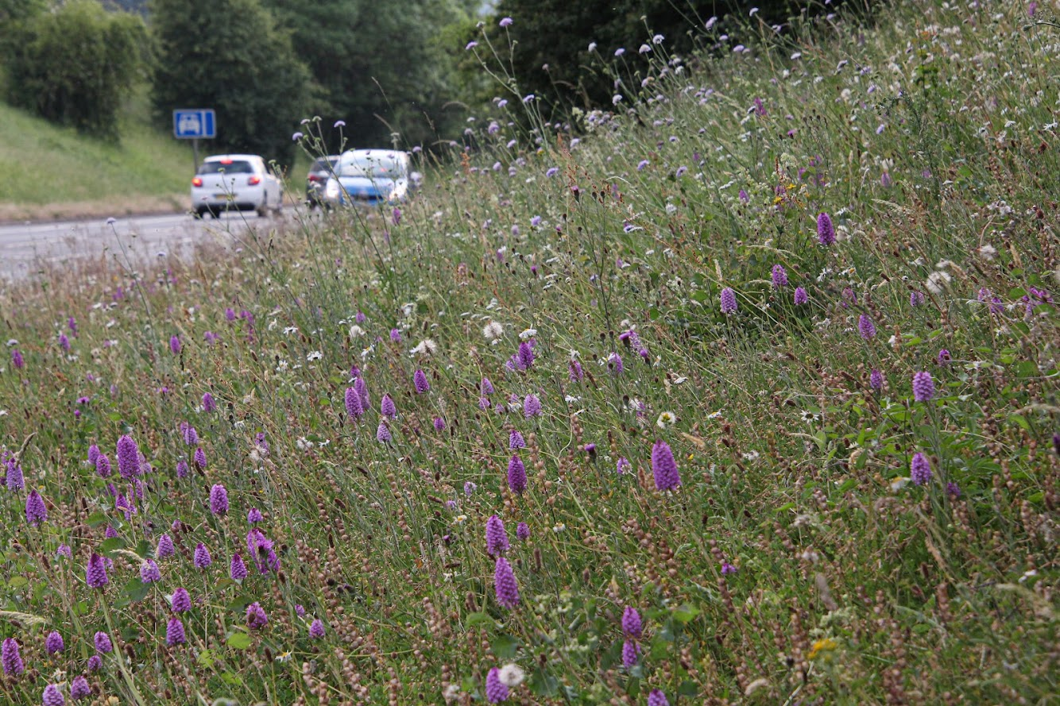
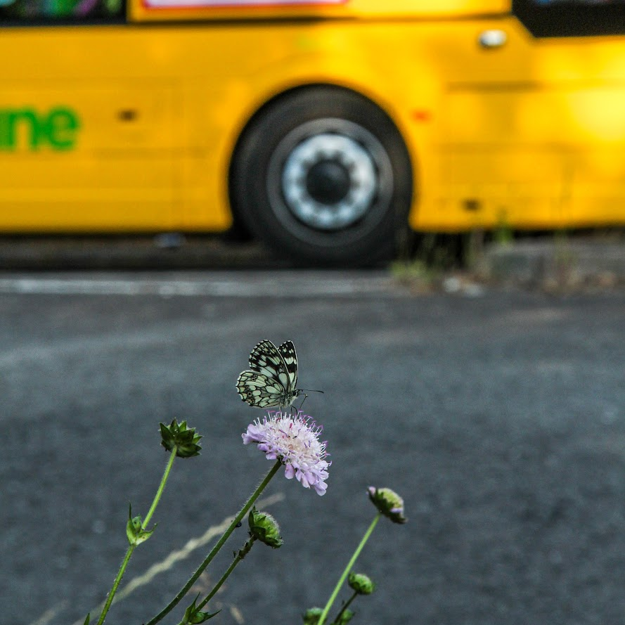
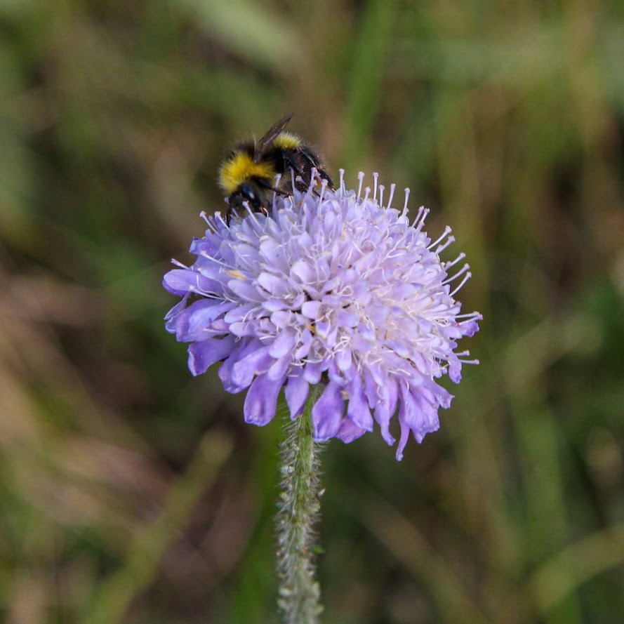

Thanks to Liz Milner for photos

# # # # #
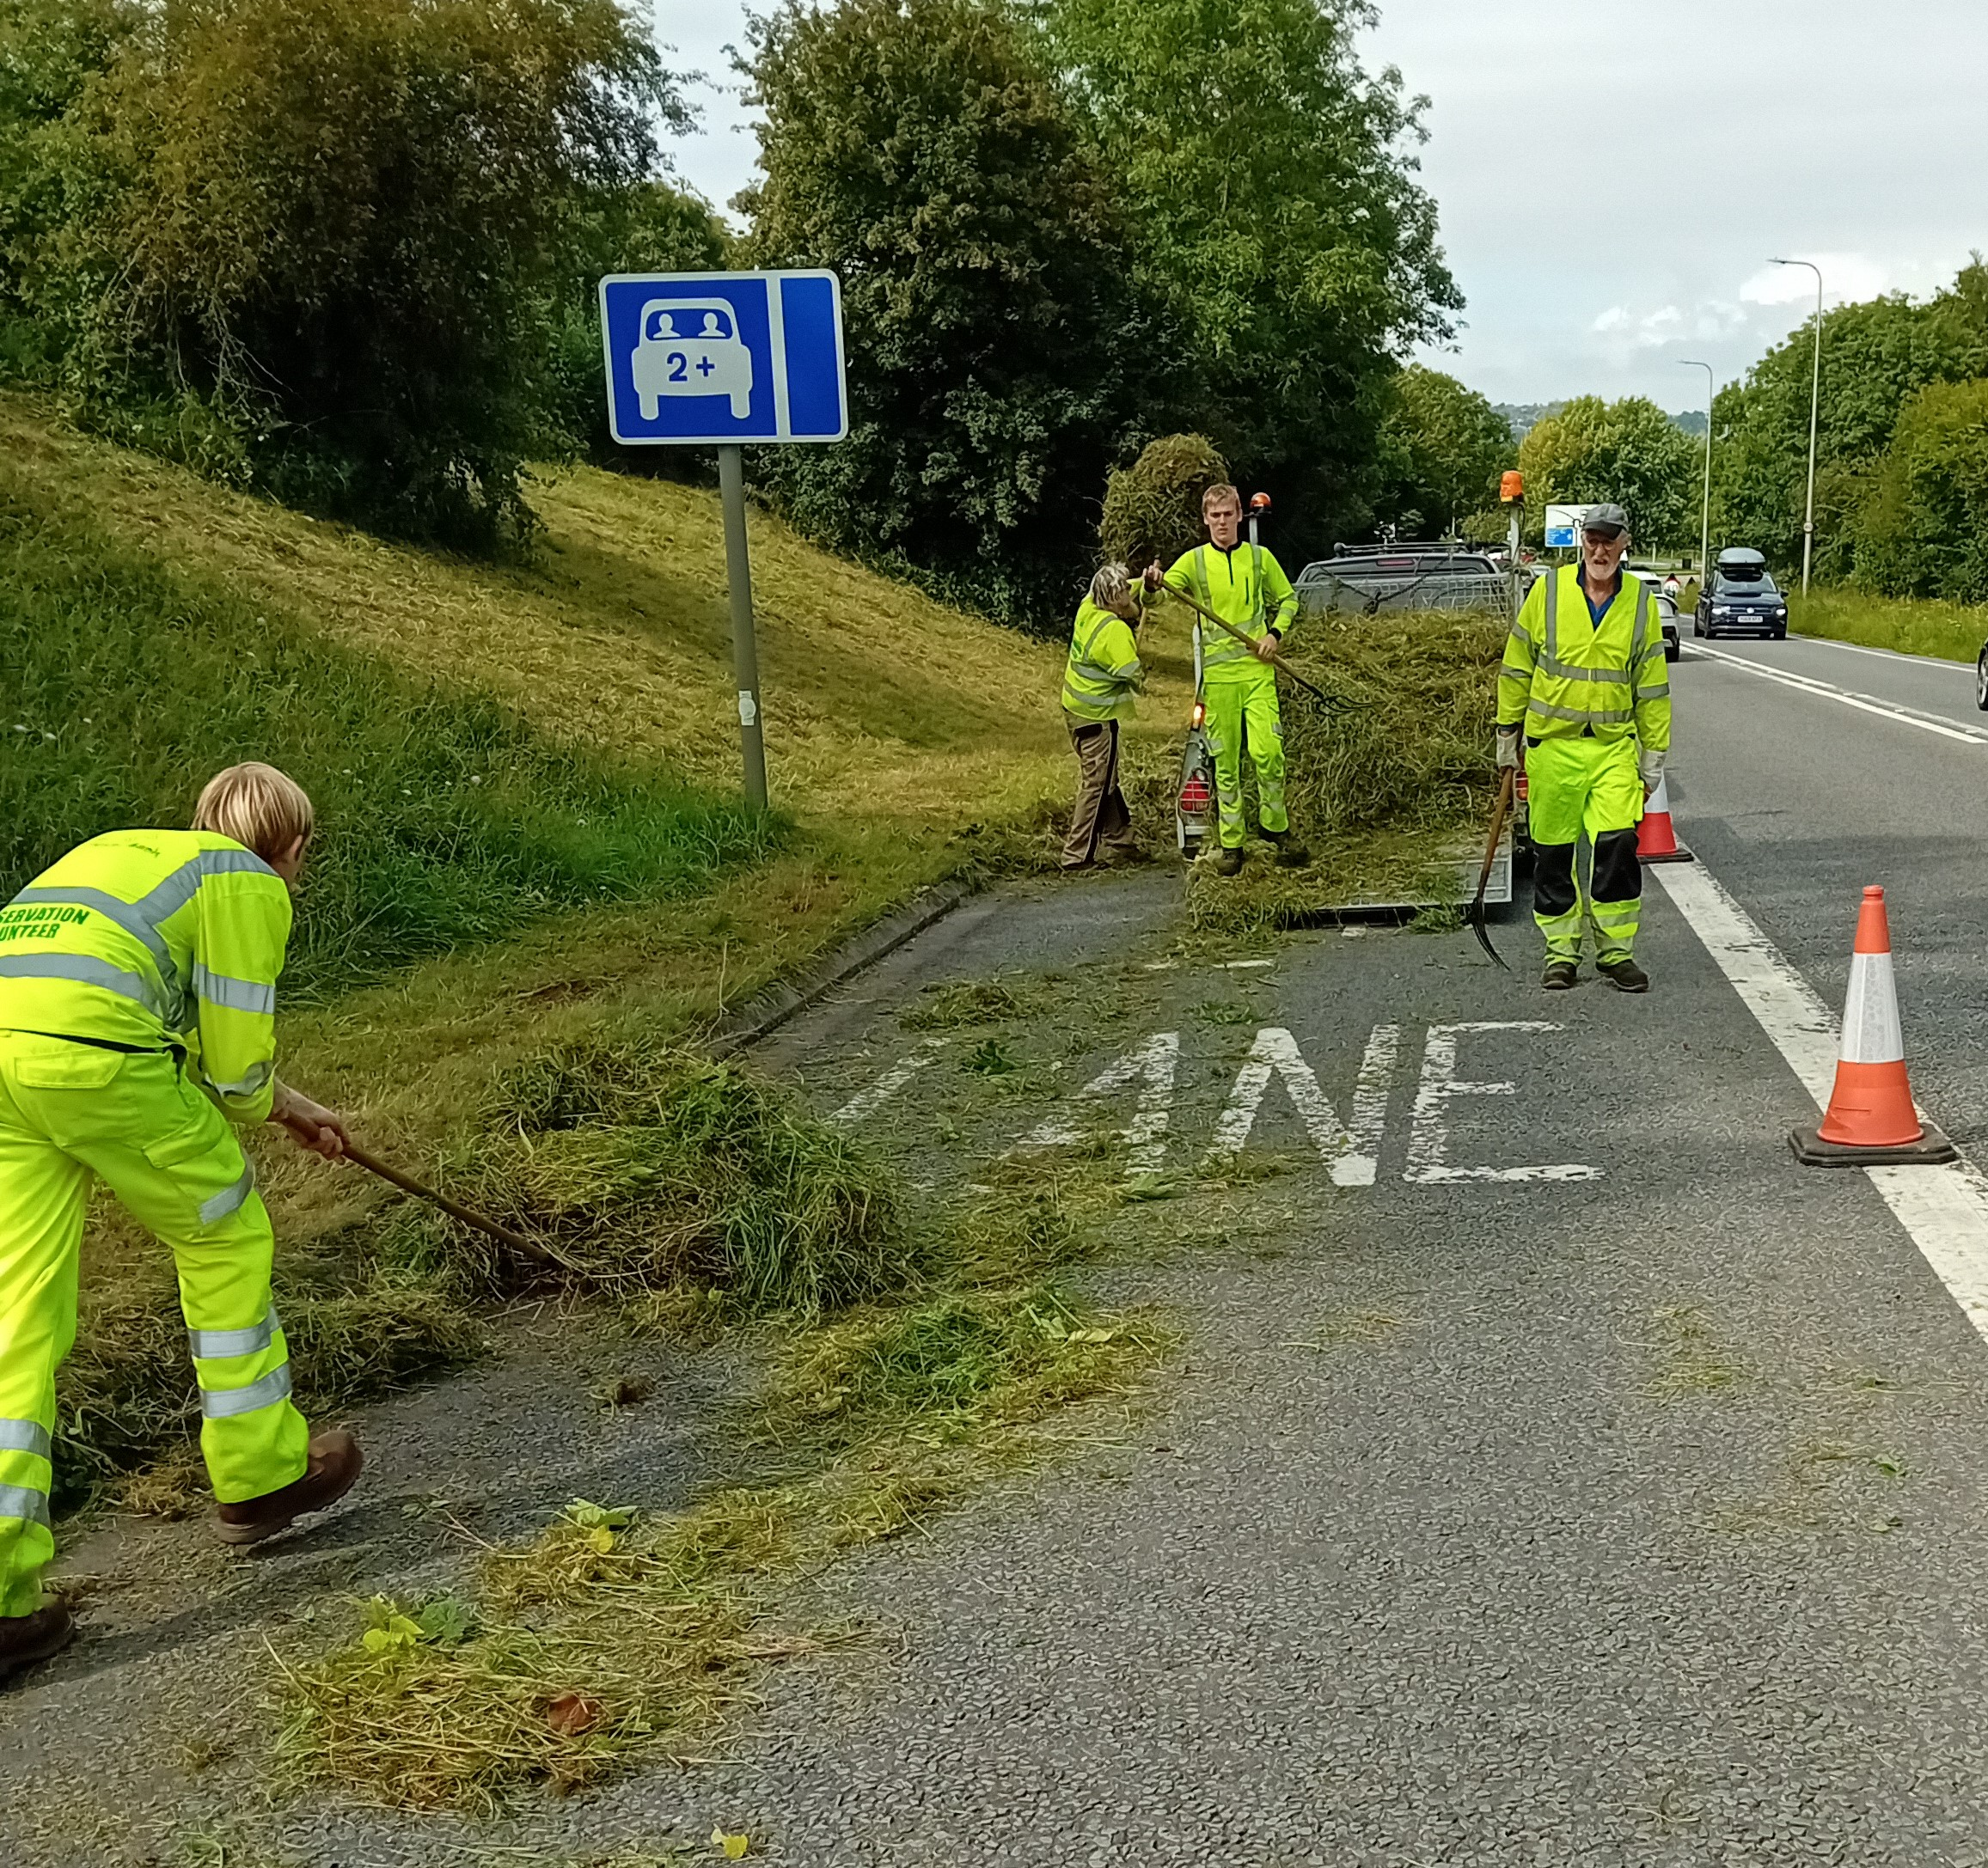
The drab damp ‘Summer’ has meant the grass has grown tremendously. We had very successful workparties to do the main haycut last month and will finish off the rest soon.

# # # # #

Avon Wildlife Trust are setting up ‘Wildlife Champions’ to get more people actively engaged
https://www.avonwildlifetrust.org.uk/wildlife-champions
If you’d like to get involved please contact Lucy Byrne - ljwbyrne@yahoo.com
# # # # #


